# GO-CLEAN

As GO-VIET expanding its business, GO-CLEAN will be the next service in Vietnam. GO-CLEAN, with the moto “***CLEANING YOUR HOME IS NO LONGER A CHORE***”, will give customer the most professional cleaning service at anytime and anywhere.

## About GO-CLEAN

GO-CLEAN is an app-based professional cleaning service which available in many large Indonesian cities.

GO-CLEAN’s customers will choose from the app with 4 main categories are **Building types**, **Main services**, **Amount of cleaners**, **Time/date** and **Address**. In addition to those main tasks, customers also can choose **additional services** too. This is the current list of each categories that this service provide.

Building types:

* Houses
* Lodging Rooms
* Apartments
* Shops

Main Services:

* Sweeping
* Mopping
* Dusting
* Bathroom cleaning \**Deep cleaning is not included(e.g. grout cleaning)*
* Room cleaning

Additional services:

* Ironing and Folding
* Cabinet cleaning
* Refrigerator cleaning
* Washing up
* Kitchen cleaning
* Stove cleaning

Here is the sample of ordering service.

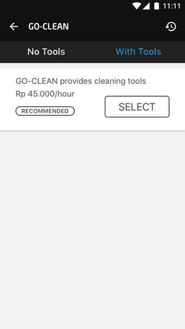 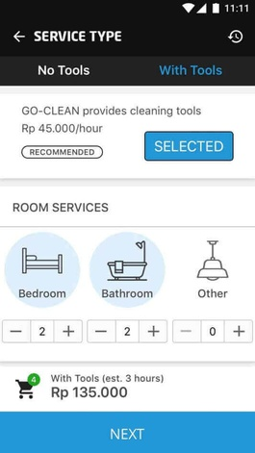 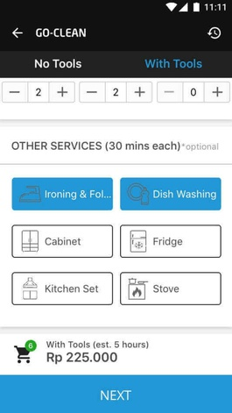

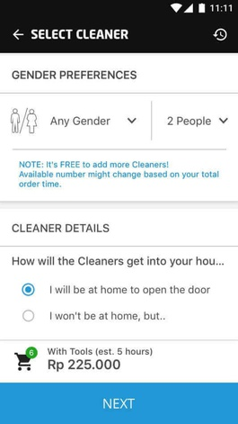 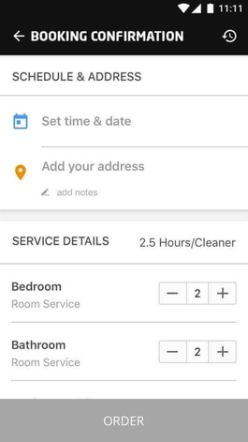 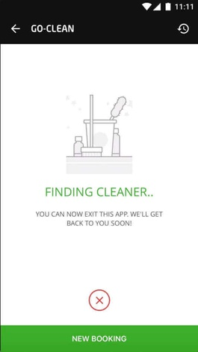

In the side of cleaners, GO-VIET will provide them with necessary tools and uniform to operate services and proper training to perform cleaning like conversation with customers or standards of cleaning. In additional to that, GO-VIET also provide a ranking system to promote cleaners with high rating.

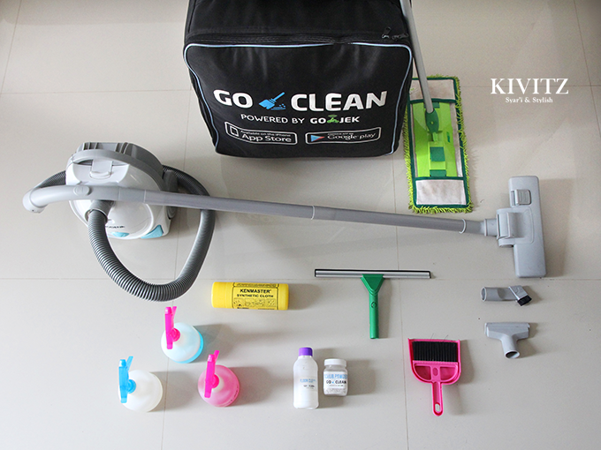

GO-CLEAN tools box

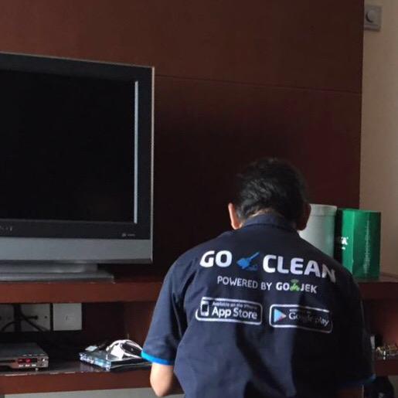

GO-CLEAN uniforms

## Why GO-CLEAN

* We have more than 700 skillful and friendly employees in cleaning field. Moreover, all of them are selected carefully and received a special training course before becoming our official staffs.
* We co-operate with the best provider in cleaning equipment in order to provide customers our professional service.
* GO-CLEAN is active 24/7. That is mean, you can call us any time you want. In addition, we work with many elite partners, so customers do not worry our service.
* We know there are many families have limit budget. However, they still want to use our service. That is why we create a list of option services which can help customers choose what they really need.

**Customer response:**

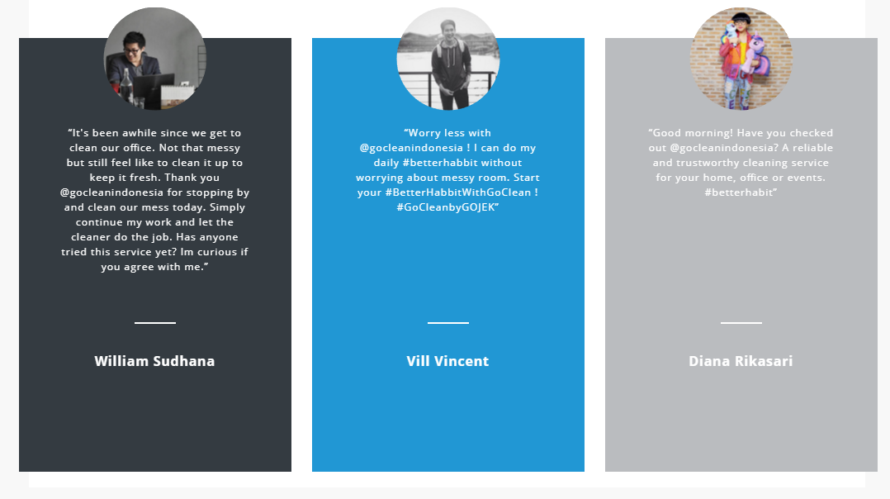

**Source :** [www.go-jek.com/go-clean](http://www.go-jek.com/go-clean)

**Our partners:**

**Pak Sugeng** :

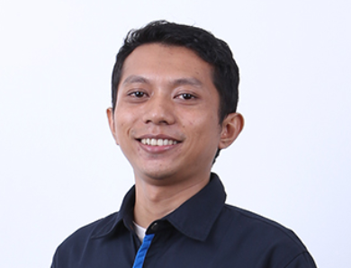

* An ex-supervisor of GO-LIFE.
* He wants to earn more money for his family. However, a full-time job will waste too much time.
* He retired from his previous job and focus on GO-CLEAN.
* He creates a connection between him and other people from various jobs.
* He can help his wife establish a food online base on his connection. From

**Nuridah** :

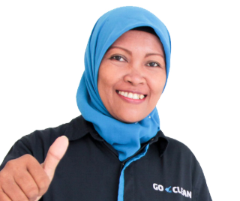

* She is a mother who truly inspire us.
* She works as a GO-JEK driver and GO-CLEAN cleaner.
* She can save enough money for her eldest child to study at the University of Indonesia.